Main content

2.3The Business Case
During the systems planning phase, the IT team reviews a request to determine if it presents a strong business case. The term business case refers to the reasons, or justification, for a proposal. To perform the review, the analyst must consider the company’s overall mission, objectives, and IT needs.
A business case should be comprehensive yet easy to understand. It should describe the project clearly, provide the justification to proceed, and estimate the project’s financial impact. Specifically, the business case should answer questions such as the following:
- Why are we doing this project?
- What is the project about?
- How does this solution address key business issues?
- How much will it cost and how long will it take?
- Will we suffer a productivity loss during the transition?
- What is the return on investment and payback period?
- What are the risks of doing the project? What are the risks of not doing the project?
- How will we measure success?
- What alternatives exist?
Examples of business cases, both good and bad, can be found online. Just search for “sample business case” and examine the structure and content of some of the samples available. It is particularly instructive to compare and contrast business cases for different areas, such as those for government contracts versus private enterprises.
Change font size
help
Main content

2.4Systems Requests
The starting point for most information systems projects is called a systems request, which is a formal way of asking for IT support. A systems request might propose enhancements for an existing system, the correction of problems, the replacement of an older system, or the development of an entirely new information system that is needed to support a company’s current and future business needs.
As Figure 2-4 shows, the six main reasons for systems requests are stronger controls, reduced cost, more information, better performance, improved service to customers, and more support for new products and services.
Figure 2-4
Six main reasons for systems requests.
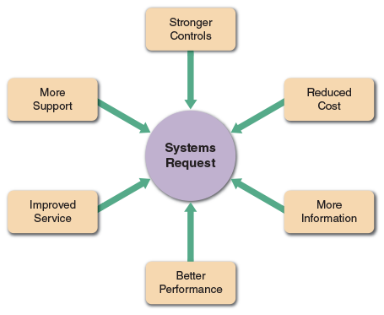

Stronger Controls
A system must have effective controls to ensure that data is secure and accurate. This is becoming increasingly important given the number of data breaches that seem to occur on a daily basis. Some common security controls include passwords, various levels of user access, and encryption, or coding data to keep it safe from unauthorized users. Hardware-based security controls include biometric devices that can identify a person by a retina scan or by mapping a fingerprint pattern. The technology uses infrared scanners that create images with thousands of measurements of personal physical characteristics, as shown in Figure 2-5, which displays Apple’s Face ID security mechanism on the iPhone.
Figure 2-5
Apple Face ID uses advanced machine learning to recognize users.

Source: Apple Inc.
In addition to being secure, data also must be accurate. Controls should minimize data entry errors whenever possible. For example, if a user enters an invalid customer number, the order processing system should reject the entry immediately and prompt the user to enter a valid number. Data entry controls must be effective without being excessive. If a system requires users to confirm every item with an “Are you sure? Y/N” message, internal users and customers might complain that the system is not user-friendly.

Reduced Cost
The current system could be expensive to operate or maintain as a result of technical problems, design weaknesses, or the changing demands of the business. It might be possible to adapt the system to newer technology or upgrade it. On the other hand, cost-benefit analysis might show that a new system would be more cost effective and provide better support for long-term objectives.

More Information
The system might produce information that is insufficient, incomplete, or unable to support the company’s changing information needs. For example, a system that tracks customer orders might not be capable of analyzing and predicting marketing trends. In the face of intense competition and rapid product development cycles, managers need the best possible information to make major decisions on planning, designing, and marketing new products and services.

Better Performance
The current system might not meet performance requirements. For example, it might respond slowly to data inquiries at certain times, or it might be unable to support company growth. Performance limitations also result when a system that was designed for a specific hardware configuration becomes obsolete when new hardware is introduced.

Improved Service
Systems requests often are aimed at improving service to customers or users within the company. For instance, allowing mutual fund investors to check their account balances on a website, storing data on rental car customer preferences, or creating an online college registration system are all examples of providing valuable services and increased customer satisfaction.

More Support for New Products and Services
New products and services often require new types or levels of IT support. For example, a software vendor might offer an automatic upgrade service for subscribers; or a package delivery company might add a special service for RFID-tagged shipments. In situations like these, it is most likely that additional IT support will be required. At the other end of the spectrum, product obsolescence can also be an important factor in IT planning. As new products enter the marketplace, vendors often announce that they will no longer provide support for older versions. A lack of vendor support would be an important consideration in deciding whether or not to upgrade.
Change font size
help
Main content

2.5Factors Affecting Systems Projects
Internal and external factors affect every business decision that a company makes, and IT projects are no exception. Figure 2-6 shows internal and external factors that shape corporate IT choices.
Figure 2-6
Internal and external factors that affect IT projects.
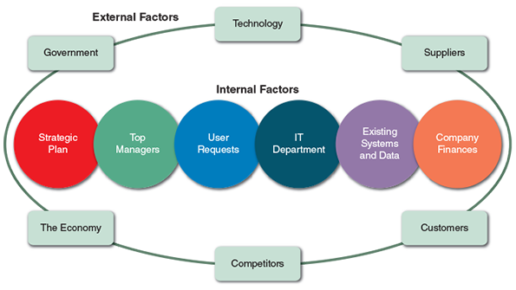
Change font size
help
Main content

2.5.1Internal Factors
Internal factors include the strategic plan, top managers, user requests, information technology department, existing systems and data, and company finances.

Strategic Plan
A company’s strategic plan sets the overall direction for the firm and has an important impact on IT projects. Company goals and objectives that need IT support will generate systems requests and influence IT priorities. A strategic plan that stresses technology tends to create a favorable climate for IT projects that extends throughout the organization.

Top Managers
Because significant resources are required, top management usually initiates large-scale projects. Those decisions often result from strategic business goals that require new IT systems, more information for decision making processes, or better support for mission-critical information systems.

User Requests
As users rely more heavily on information systems to perform their jobs, they are likely to request even more IT services and support. For example, sales reps might request improvements to the company’s website, a more powerful sales analysis report, a network to link all sales locations, or an online system that allows customers to obtain the status of their orders instantly. Or, users might not be satisfied with the current system because it is difficult to learn or lacks flexibility. They might want information systems support for business requirements that did not even exist when the system was first developed.

Information Technology Department
Systems project requests come also from the IT department itself. IT staff members often make recommendations based on their knowledge of business operations and technology trends. IT proposals might be strictly technical matters, such as replacement of certain network components, or suggestions might be more business oriented, such as proposing a new reporting or data collection system.

Existing Systems and Data
Errors or problems in existing systems can trigger requests for systems projects. When dealing with older systems, analysts sometimes spend too much time reacting to day-to-day problems without looking at underlying causes. This approach can turn an information system into a patchwork of corrections and changes that cannot support the company’s overall business needs. This problem typically occurs with legacy systems, which are older systems that are less technologically advanced. When migrating to a new system, IT planners must plan the conversion of existing data, which is described in detail in Chapter 11.

Company Finances
A company’s financial status can affect systems projects. If the company is going through a difficult time, the project may be postponed until there is more cash available to finance the effort. On the other hand, if the company is enjoying financial success, the decision to embark on a new project may be easier to make.
Change font size
help
Main content

2.5.2External Factors
External factors include technology, suppliers, customers, competitors, the economy, and government.

Technology
Changing technology is a major force affecting business and society in general. For example, the rapid growth of telecommunications, coupled with increased computing power and continuous miniaturization of electronic components, has created entire new industries and technologies, including the proliferation of smartphones and the app ecosystem.
Technology also dramatically reshapes existing business operations. The success of scanner technology resulted in universal bar coding that now affects virtually all products. Some industry experts predict that bar code technology, which is over 40 years old, will be overshadowed in the future by electronic product code (EPC) technology that uses RFID tags to identify and monitor the movement of each individual product, from the factory floor to the retail checkout counter.
Quick Response codes (QR Codes), as shown in Figure 2-7, are like bar codes but square in shape. They contain more information than traditional bar codes, but less than RFID tags. They do have the advantage of being less expensive to use than RFID tags, and they can be printed on almost anything—including online advertisements.
Figure 2-7
QR Code.

Source: http://www.qrstuff.com using URL http://amazon.com/author/stilley
The Internet-of-Things (IOT) is a newer development that involves almost all electronic devices communicating with one another over a computer network. The communication can use radio signals, as with RFID tags, digital messages, or other means. IoT devices can act as sensors, sending important information to centralized data storage and processing nodes. IoT devices also raise new security and privacy concerns that the systems analyst must consider.

Suppliers
With the growth of electronic data interchange (EDI), relationships with suppliers are critically important. For example, an automobile company might require that suppliers code their parts in a certain manner to match the auto company’s inventory control system. EDI also enables just-in-time (JIT) inventory systems that rely on computer-to-computer data exchange to minimize unnecessary inventory. The purpose of a JIT system is to provide the right products at the right place at the right time.
Blockchain technology is a promising mechanism for managing supply chains more powerfully than before. Blockchain provides a distributed ledger system that is efficient, secure, transparent. Large companies such as IBM are already using blockchain to improve operations for their customers, such as the Food Trust product shown in Figure 2-8 that Walmart uses for tracking food safety from grower to consumer.
Figure 2-8
IBM Blockchain.
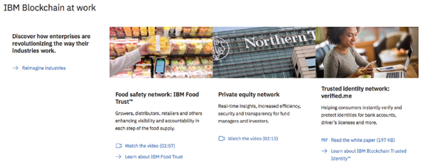
Source: IBM Corporation

Customers
Customers are vitally important to any business. Information systems that interact with customers usually receive top priority. Many companies implement customer relationship management (CRM) systems that integrate all customer-related events and transactions, including marketing, sales, and customer service activities. Vendor-oriented CRM systems often interconnect with supply chain management (SCM) systems, which were discussed in Chapter 1. CRM components can provide automated responses to sales inquiries, online order processing, and inventory tracking. Some suppliers use robots for order fulfillment, such as the Kiva robots shown in Figure 2-9 that Amazon.com uses in their warehouses.
Figure 2-9
Amazon Robotics’ Kiva robots.
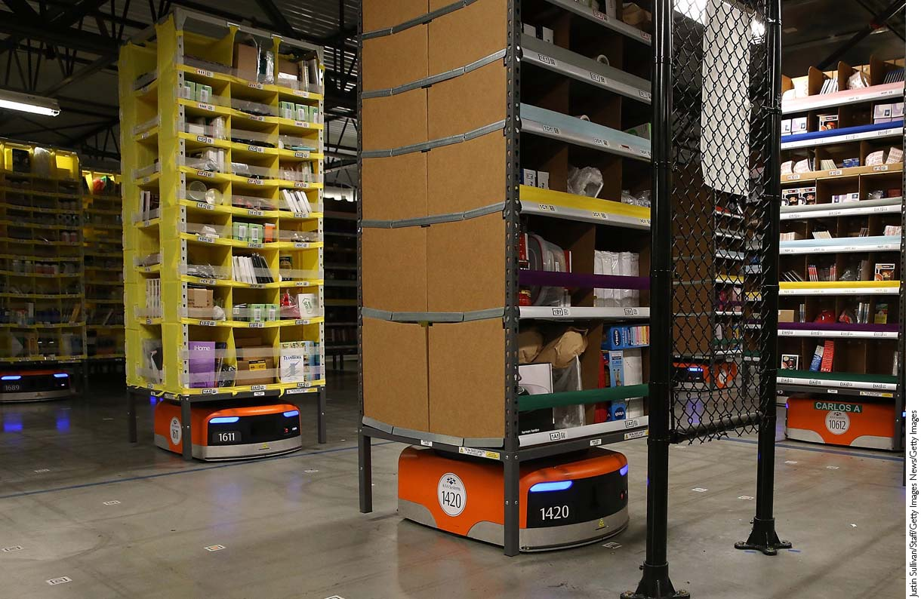
Justin Sullivan/Staff/Getty Images News/Getty Images
Another RFID application is called electronic proof of delivery (EPOD). Using EPOD, a supplier uses RFID tags on each crate, case, or shipping unit to create a digital shipping list. The customer receives the list and scans the incoming shipment. If a discrepancy is detected, it is reported and adjusted automatically. Because they would be expensive to investigate manually, small shipping inconsistencies might not otherwise be traced. This is an example of technology-related cost control.

Competitors
Competition drives many information systems decisions. For example, if one cellular telephone provider offers a new type of digital service, other firms must match the plan in order to remain competitive. New product research and development, marketing, sales, and service all require IT support.

The Economy
Economic activity has a powerful influence on corporate information management. In a period of economic expansion, firms need to be ready with scalable systems that can handle additional volume and growth. Predicting the business cycle is not an exact science, and careful research and planning are important.

Government
Federal, state, and local government regulations directly affect the design of corporate information systems. For example, up-to-date IRS reporting requirements must be designed into a payroll package.
Change font size
help
Main content

2.6Processing Systems Requests
In most organizations, the IT department receives more systems requests than it can handle. Many organizations assign responsibility for evaluating systems requests to a group of key managers and users. Many companies call this group a systems review committee or a computer resources committee. Regardless of the name, the objective is to use the combined judgment and experience of several analysts to evaluate project requests.
Change font size
help
Main content

2.6.1Systems Request Forms
Many organizations use a special form for systems requests, similar to the online sample shown in Figure 2-10. A properly designed form streamlines the request process and ensures consistency. The form must be easy to understand and include clear instructions. It should include enough space for all required information and should indicate what supporting documents are needed. Most companies use online systems request forms that users submit electronically because the form can be processed automatically.
Figure 2-10
Example of an online systems request form.
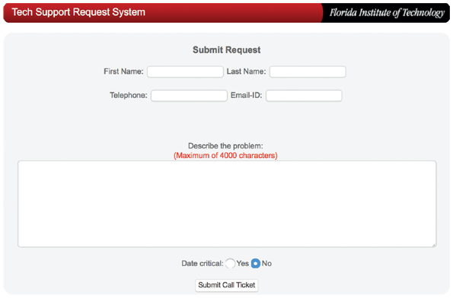
Source: Florida Institute of Technology
When a systems request form is received, a systems analyst or IT manager examines it to determine what IT resources are required for the preliminary investigation. A designated person or a committee then decides whether to proceed with a preliminary investigation. Sometimes, a situation requires an immediate response. For example, if the problem involves a mission-critical system, an IT maintenance team must restore normal operations immediately. When the system is functioning properly, the team conducts a review and prepares a systems request to document the work that was performed.
Change font size
help
Main content

2.6.2Systems Request Tools
When the number of requests submitted through automated forms becomes significant, or if the requests can originate from internal sources as well as external customers, special-purpose systems request tools can be used to help manage the workflow. For example, Figure 2-11 illustrates the service request capabilities from Integrify that captures, manages, and routes requests to systems analysts based on definable business rules. In this way, requests are tracked and analyzed for improved performance.
Figure 2-11
A service request management system from Integrify.
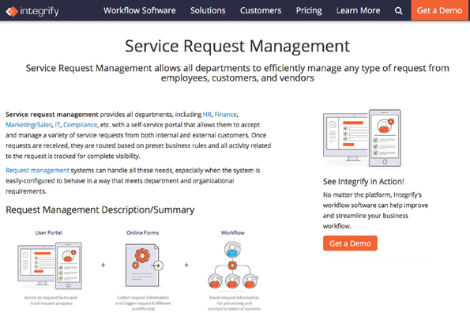
Source: Integrify
Change font size
help
Main content

2.6.3Systems Review Committee
Most large companies use a systems review committee to evaluate systems requests. Instead of relying on a single individual, a committee approach provides a variety of experience and knowledge. With a broader viewpoint, a committee can establish priorities more effectively than an individual, and one person’s bias is less likely to affect the decisions.
A typical committee consists of the IT director and several managers or representatives from other departments. The IT director usually serves as a technical consultant to ensure that committee members are aware of crucial issues, problems, and opportunities.
Although a committee offers many advantages, some disadvantages exist. For example, action on requests must wait until the committee meets. Another potential disadvantage of a committee is that members might favor projects requested by their own departments, and internal political differences could delay important decisions.
Many smaller companies rely on one person to evaluate system requests instead of a committee. If only one person has the necessary IT skills and experience, that person must consult closely with users and managers throughout the company to ensure that business and operational needs are considered carefully.
Whether one person or a committee is responsible, the goal is to evaluate the requests and set priorities. Suppose four requests must be reviewed:
- The marketing group wants to analyze current customer spending habits and forecast future trends.
- The technical support group wants a cellular link, so service representatives can download technical data instantly.
- The accounting department wants to redesign customer statements and allow Internet access.
- The production staff wants an inventory control system that can exchange data with major suppliers.
Which projects should the firm pursue? What criteria should be applied? How should priorities be determined? To answer those questions, the individual or the committee must assess the feasibility of each request.
Case in Point 2.2

Attaway Airlines, Part One
- You are the IT director at Attaway Airlines, a small regional air carrier. You chair the company’s systems review committee, and you currently are dealing with strong disagreements about two key projects. The marketing manager says it is vital to have a new computerized reservation system that can provide better customer service and reduce operational costs. The vice president of finance is equally adamant that a new accounting system is needed immediately because it will be very expensive to adjust the current system to new federal reporting requirements. The VP outranks the marketing manager, and the VP is your boss. The next meeting, which promises to be a real showdown, is set for 9:00 a.m. tomorrow. How will you prepare for the meeting? What questions and issues should be discussed?
Change font size
help
Main content

2.7Assessing Request Feasibility
As described in Chapter 1, a systems request must pass several tests to see whether it is worthwhile to proceed further. The first step is to identify and weed out systems requests that are not feasible. For example, a request would not be feasible if it required hardware or software that the company already had rejected.
Even if the request is feasible, it might not be necessary. For example, a request for multiple versions of a report could require considerable design and programming effort. A better alternative might be to download the server data to a personal computer-based software package and show users how to produce their own reports. In this case, training users would be a better investment than producing reports for them.
Sometimes assessing request feasibility is quite simple and can be done in a few hours. If the request involves a new system or a major change, however, extensive fact-finding and investigation in the form of feasibility studies are required.
Change font size
help
Main content

2.7.1Feasibility Studies
As shown in Figure 2-12, a feasibility study uses four main yardsticks to measure a proposal: operational feasibility, economic feasibility, technical feasibility, and schedule feasibility.
Figure 2-12
A feasibility study examines operational, technical, economic, and schedule factors.
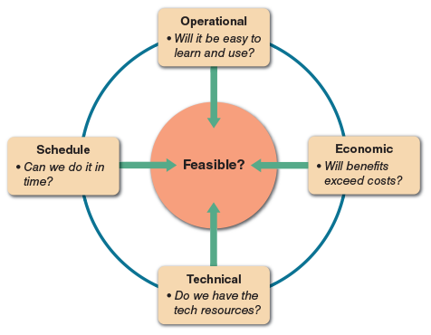
How much effort should go into a feasibility study depends on nature of the request. For example, if a department wants an existing report sorted in a different order, the analyst can decide quickly whether the request is feasible. On the other hand, a proposal by the marketing department for a new market research system to predict sales trends would require much more effort. In either case, the systems analyst should ask these important questions:
- Is the proposal desirable in an operational sense? Is it a practical approach that will solve a problem or take advantage of an opportunity to achieve company goals?
- Is the proposal technically feasible? Are the necessary technical resources and people available for the project?
- Is the proposal economically desirable? What are the projected savings and costs? Are other intangible factors involved, such as customer satisfaction or company image? Is the problem worth solving, and will the request result in a sound business investment?
- Can the proposal be accomplished within an acceptable time frame?
To obtain more information about a systems request, initial fact-finding might be accomplished by studying organization charts, performing interviews, reviewing current documentation, observing operations, and surveying users. Sometimes, developing prototypes can provide additional insight into the feasibility of the request. If the systems request is approved, more intensive fact-finding will continue during the systems analysis phase.
Change font size
help
Main content

2.7.2Operational Feasibility
Operational feasibility means that a proposed system will be used effectively after it has been developed. If users have difficulty with a new system, it will not produce the expected benefits. Organizational culture can also affect operational feasibility. For instance, a system that works well in a highly structured workplace might be very unpopular in a more relaxed corporate culture. Operational feasibility is difficult to measure with precision but must be studied very carefully. The following questions would help predict a system’s operational feasibility:
- Does management support the project? Do users support the project? Is the current system well liked and effectively used? Do users see the need for change?
- Will the new system result in a workforce reduction? If so, what will happen to the affected employees?
- Will the new system require training for users? If so, is the company prepared to provide the necessary resources for training current employees?
- Will users be involved in planning the new system right from the start?
- Will the new system place any new demands on users or require any operating changes? For example, will any information be less accessible or produced less frequently? Will performance decline in any way? If so, will an overall gain to the organization outweigh individual losses?
- Will customers experience adverse effects in any way, either temporarily or permanently?
- Will any risk to the company’s image or goodwill result?
- Does the development schedule conflict with other company priorities?
- Do legal or ethical issues need to be considered?
Change font size
help
Main content

2.7.3Economic Feasibility
Economic feasibility means that the projected benefits of the proposed system outweigh the estimated costs usually considered the total cost of ownership (TCO), which includes ongoing support and maintenance costs, as well as acquisition costs. To determine TCO, the analyst must estimate costs in each of the following areas:
- People, including IT staff and users
- Hardware and equipment
- Software, including in-house development as well as purchases from vendors
- Formal and informal training, including peer-to-peer support
- Licenses and fees
- Consulting expenses
- Facility costs
- The estimated cost of not developing the system or postponing the project
Tangible costs, such as those listed above, usually can be measured in dollars. But intangible costs also must be considered. For example, low employee morale might not have an immediate dollar impact, but certainly will affect the company’s performance.
In addition to costs, tangible and intangible benefits to the company must be assessed. The systems review committee will use those figures, along with the cost estimates, to decide whether to pursue the project beyond the preliminary investigation phase.
Tangible benefits are benefits that can be measured in dollars. Tangible benefits result from a decrease in expenses, an increase in revenues, or both. Examples of tangible benefits include the following:
- A new scheduling system that reduces overtime
- An online package tracking system that improves service and decreases the need for clerical staff
- A sophisticated inventory control system that cuts excess inventory and eliminates production delays
Intangible benefits are advantages that are difficult to measure in dollars but are important to the company. Examples of intangible benefits include the following:
- A user-friendly system that improves employee job satisfaction
- A sales tracking system that supplies better information for marketing decisions
- A new website that enhances the company’s image
The development timetable must also be considered, because some benefits might occur as soon as the system is operational, but others might not take place until later.
Change font size
help
Main content

2.7.4Technical Feasibility
Technical feasibility refers to the technical resources needed to develop, purchase, install, or operate the system. When assessing technical feasibility, an analyst should consider the following points:
- Does the company have the necessary hardware, software, and network resources? If not, can those resources be acquired without difficulty?
- Does the company have the needed technical expertise? If not, can it be acquired?
- Does the proposed platform have sufficient capacity for future needs? If not, can it be expanded?
- Will a prototype be required?
- Will the hardware and software environment be reliable? Will it integrate with other company information systems, both now and in the future? Will it interface properly with external systems operated by customers and suppliers?
- Will the combination of hardware and software supply adequate performance? Do clear expectations and performance specifications exist?
- Will the system be able to handle future transaction volume and company growth?
Keep in mind that systems requests that are not currently technically feasible can be resubmitted as new hardware, software, or expertise becomes available. Development costs might decrease, or the value of benefits might increase enough that a systems request eventually becomes feasible. Conversely, an initially feasible project can be rejected later.
Change font size
help
Main content

2.7.5Schedule Feasibility
Schedule feasibility means that a project can be implemented in an acceptable time frame. When assessing schedule feasibility, a systems analyst must consider the interaction between time and costs. For example, speeding up a project schedule might make a project feasible, but much more expensive.
Other issues that relate to schedule feasibility include the following:
- Can the company or the IT team control the factors that affect schedule feasibility?
- Has management established a firm timetable for the project?
- What conditions must be satisfied during the development of the system?
- Will an accelerated schedule pose any risks? If so, are the risks acceptable?
- Will project management techniques be available to coordinate and control the project?
- Will a project manager be appointed?
Chapter 3 describes various project management tools and techniques.
Change font size
help
Main content

2.8Setting Priorities
After rejecting systems requests that are not feasible, the systems review committee must establish priorities for the remaining items. If tools are used as part of the review process, the requests may already be in a partially or fully sorted order. The highest priority goes to project requests that provide the greatest benefit, at the lowest cost, in the shortest period of time. Many factors, however, influence project evaluation.
Change font size
help
Main content

2.8.1Dynamic Priorities
It’s important to note that many projects are dynamic in nature. For example, projects that have adopted an agile methodology are prone to rapid changes throughout the system development lifecycle. These changes can cause request priorities to change as well.
For example, acquisition costs might increase over time, making the project more expensive than anticipated. This can affect the economic feasibility of a number of requests. In addition, managers and users sometimes lose confidence in a project. For all those reasons, feasibility analysis and priority setting are ongoing task that must be performed throughout the systems development process.
Change font size
help
Main content

2.8.2Factors That Affect Priority
When assessing a project’s priority, a systems analyst should consider the following:
- Will the proposed system reduce costs? Where? When? How? By how much?
- Will the system increase revenue for the company? Where? When? How? By how much?
- Will the systems project result in more information or produce better results? How? Are the results measurable?
- Will the system serve customers better?
- Will the system serve the organization better?
- Can the project be implemented in a reasonable time period? How long will the results last?
- Are the necessary financial, human, and technical resources available?
Few projects will score high in all areas. Some proposals might not reduce costs but will provide important new features. Other systems might reduce operating costs substantially but require the purchase or lease of additional hardware. Some systems might be very desirable but require several years of development before producing significant benefits.
Whenever possible, the analyst should use tangible costs and benefits that can be measured in dollars. However, the proposal might involve intangible benefits, such as enhancing the organization’s image, raising employee morale, or improving customer service. These examples are harder to measure but should also be considered.
Change font size
help
Main content

2.8.3Discretionary and Nondiscretionary Projects
Projects where management has a choice in implementing them are called discretionary projects. Projects where no choice exists are called nondiscretionary projects. Creating a new report for a user is an example of a discretionary project; adding a report required by a new federal law is an example of a nondiscretionary project.
If a particular project is not discretionary, the systems analyst should ask if it is really necessary for the systems review committee to evaluate it. Some people believe that waiting for committee approval delays critical nondiscretionary projects unnecessarily. Others believe that submitting all requests to the systems review keeps the committee aware of all projects that compete for IT resources. As a result, the committee can review priorities and create realistic schedules.
Many nondiscretionary projects are predictable. Examples include annual updates to payroll, tax percentages, or quarterly changes in reporting requirements for an insurance processing system. By planning ahead for predictable projects, the IT department manages its resources better and keeps the systems review committee fully informed without needing prior approval in every case.
Case in Point 2.3

Attaway Airlines, Part Two
- Back at Attaway Airlines, the morning meeting ended with no agreement between the VP of finance and the marketing manager. In fact, a new issue arose. The VP now says that the new accounting system is entitled to the highest priority because the federal government soon will require the reporting of certain types of company-paid health insurance premiums. Because the current system will not handle this report, the VP insists that the entire accounting system is a nondiscretionary project. As you might expect, the marketing manager is upset. Can part of a project be nondiscretionary? What issues need to be discussed? The committee meets again tomorrow, and the members will look to you, as the IT director, for guidance.
Change font size
help
Main content

2.9The Preliminary Investigation
A systems analyst conducts a preliminary investigation to study the systems request and recommend specific action. After obtaining an authorization to proceed, the analyst interacts with managers, users, and other stakeholders, as shown in the model in Figure 2-13. The analyst gathers facts about the problem or opportunity, project scope and constraints, project benefits, and estimated development time and costs. The end product of the preliminary investigation is a report to management.
Figure 2-13
Model of a preliminary investigation. Note the importance of fact-finding in each of the four areas.
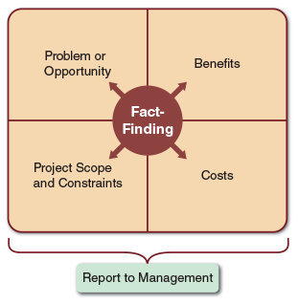
Change font size
help
Main content

2.9.1Planning the Preliminary Investigation
Before starting a preliminary investigation, it is important to let people know about the investigation and explain the role of the system analyst. Meetings with key managers, users, and other stakeholders such as the IT staff should be scheduled, to describe the project, explain roles and responsibilities, answer questions, and invite comments. Interactive communication with users starts at this point and continues throughout the development process.
A systems project often produces significant changes in company operations. Employees may be curious, concerned, or even opposed to those changes. It is not surprising to encounter some user resistance during a preliminary investigation. Employee attitudes and reactions are important and must be considered.
When interacting with users, use the word problem carefully, because it has a negative meaning. When users are asked about problems, some will stress current system limitations rather than desirable new features or enhancements. Instead of focusing on difficulties, question users about additional capability they would like to have. This approach highlights ways to improve the user’s job, provides a better understanding of operations, and builds better, more positive relationships with users.
Change font size
help
Main content

2.9.2Performing the Preliminary Investigation
During a preliminary investigation, a systems analyst typically follows a series of steps, as shown in Figure 2-14. The exact procedure depends on the nature of the request, the size of the project, and the degree of urgency.
Figure 2-14
Five main steps in a typical preliminary investigation.
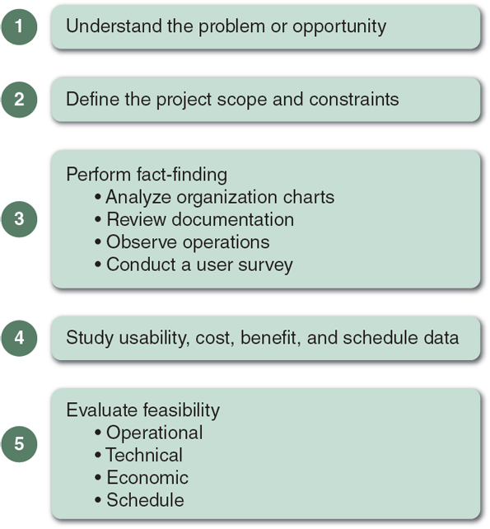

Step 1:Understand the Problem or Opportunity
If the systems request involves a new information system or a substantial change in an existing system, systems analysts might need to develop a business profile that describes current business processes and functions, as explained in Chapter 1. Even where the request involves relatively minor changes or enhancements, how those modifications will affect business operations and other information systems must be understood. Often a change in one system has an unexpected ripple effect on another system. When a systems request is analyzed, which departments, users, and business processes are involved must be determined.
In many cases, the systems request does not reveal the underlying problem, but only a symptom. For example, a request to investigate centralized processing delays might reveal improper scheduling practices rather than hardware problems. Similarly, a request for analysis of customer complaints might disclose a lack of sales representative training, rather than problems with the product.
A popular technique for investigating causes and effects is called a fishbone diagram, as shown in Figure 2-15. A fishbone diagram is an analysis tool that represents the possible causes of a problem as a graphical outline. When using a fishbone diagram, an analyst first states the problem and draws a main bone with sub-bones that represent possible causes of the problem. In the example shown in Figure 2-15, the problem is Low Morale, and the analyst has identified four areas to investigate: Environment, People, Management, and Machines. In each area, the analyst identifies possible causes and draws them as horizontal sub-bones. For example, Temp too hot or cold is a possible cause in the Environment bone. For each cause, the analyst must dig deeper and ask the question: What could be causing this symptom to occur? For example, why is it too hot? If the answer is a Faulty thermostat, the analyst indicates this as a sub-bone to the Temp too hot or cold cause. In this manner, the analyst adds additional sub-bones to the diagram, until he or she uncovers root causes of a problem, rather than just the symptoms.
Figure 2-15
A fishbone diagram displays the causes of a problem. Typically, you must dig deeper to identify actual causes rather than just symptoms
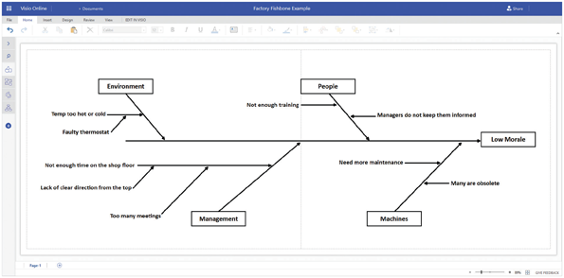

Step 2:Define the Project Scope and Constraints
Determining the project scope means defining the specific boundaries, or extent, of the project. For example, a statement that, payroll is not being produced accurately is very general, compared with the statement, overtime pay is not being calculated correctly for production workers on the second shift at the Yorktown plant. Similarly, the statement, the project scope is to modify the accounts receivable system, is not as specific as the statement, the project scope is to allow customers to inquire online about account balances and recent transactions.
Some analysts find it helpful to define project scope by creating a list with sections called Must Do, Should Do, Could Do, and Won’t Do. This list can be reviewed later, during the systems analysis phase, when the systems requirements document is developed.
Projects with very general scope definitions are at risk of expanding gradually, without specific authorization, in a process called project creep. To avoid this problem, project scope should be defined as clearly as possible. A graphical model that shows the systems, people, and business processes that will be affected is sometimes useful. The scope of the project also establishes the boundaries of the preliminary investigation itself. A systems analyst should limit the focus to the problem at hand and avoid unnecessary expenditure of time and money.
Along with defining the scope of the project, any constraints on the system must be identified. A constraint is a requirement or condition that the system must satisfy or an outcome that the system must achieve. A constraint can involve hardware, software, time, policy, law, or cost. System constraints also define project scope. For example, if the system must operate with existing hardware, that is a constraint that affects potential solutions. Other examples of constraints are:
- The order entry system must accept input from 15 remote sites.
- The human resources information system must produce statistics on hiring practices.
- The new website must be operational by March 1.
When examining constraints, their characteristics should be identified, as follows.

Present versus Future
Is the constraint something that must be met as soon as the system is developed or modified, or is the constraint necessary at some future time?

Internal versus Externall
Is the constraint due to a requirement within the organization, or does some external force, such as government regulation, impose it?

Mandatory versus Desirable
Is the constraint mandatory? Is it absolutely essential to meet the constraint, or is it merely desirable?
Figure 2-16 shows five examples of constraints. Notice that each constraint has three characteristics, which are indicated by its position in the figure and by the symbol that represents the constraint, as follows:
- The constraint in Example A is present, external, and mandatory.
- The constraint in Example B is future, external, and mandatory.
- The constraint in Example C is present, internal, and desirable.
- The constraint in Example D is present, internal, and mandatory.
- The constraint in Example E is future, internal, and desirable.
Figure 2-16
Examples of various types of constraints.
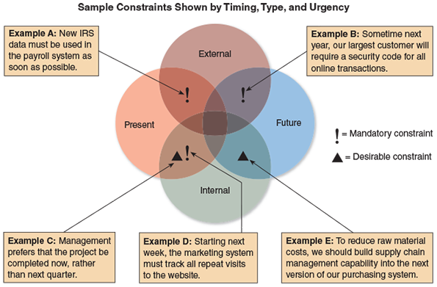
Regardless of the type, all constraints should be identified as early as possible to avoid future problems and surprises. A clear definition of project scope and constraints avoids misunderstandings that arise when managers assume that the system will have a certain feature or support for a project, but later find that the feature is not included.

Step 3:Perform Fact-Finding
The objective of fact-finding is to gather data about project usability, costs, benefits, and schedules. Fact-finding involves various techniques, which are described below. Depending on what information is needed to investigate the systems request, fact-finding might consume several hours, days, or weeks. For example, a change in a report format or data entry screen might require a single telephone call or email message to a user, whereas a new inventory system would involve a series of interviews. During fact-finding, the analyst might analyze organization charts, conduct interviews, review current documentation, observe operations, and carry out a user survey.

Analyze Organization Charts
An analyst will not always know the organizational structure of departments involved in the study. Organization charts should be obtained to understand the functions and identify people to interview.
If organization charts are not available, or are out-of-date, the necessary information should be obtained from department personnel and construct the charts, as shown in Figure 2-17.
Figure 2-17
Specialized tools such as Microsoft Visio can be used to draw organizational charts, but general purpose presentation tools such as Microsoft PowerPoint shown here can also be used.
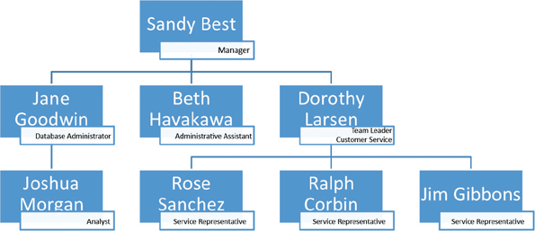
Even when charts are available, their accuracy should be verified. Keep in mind that an organization chart shows formal reporting relationships but not the informal alignment of a group, which also is important.

Conduct Interviews
The primary method of obtaining information during the preliminary investigation is the interview. The interviewing process involves a series of steps:
- 1.
Determine the people to interview.
- 2.
Establish objectives for the interview.
- 3.
Develop interview questions.
- 4.
Prepare for the interview.
- 5.
Conduct the interview.
- 6.
Document the interview.
- 7.
Evaluate the interview.
These seven steps are discussed in detail in Chapter 4, which describes fact-finding techniques that occur during the systems analysis phase of the SDLC.
Remember that the purpose of the interview, and of the preliminary investigation itself, is to uncover facts, not to convince others that the project is justified. The analyst’s primary role in an interview is to ask effective questions and listen carefully. If several people will be asked about the same topic, a standard set of questions for all the interviews should be prepared. Also be sure to include open-ended questions, such as “What else do you think I should know about the system?” or “Is there any other relevant information that we have not discussed?”
When conducting interviews during the preliminary investigation, interview managers and supervisors who have a broad knowledge of the system and can provide an overview of the business processes involved. Depending on the situation, talking to operational personnel to learn how the system functions on a day-to-day basis may also be helpful.

Review Documentation
Although interviews are an extremely important method of obtaining information, investigating the current system documentation is also useful. The documentation might not be up to date, so check with users to confirm that the information is accurate and complete.

Observe Operations
Another fact-finding method is to observe the current system in operation. Observe how workers carry out typical tasks. Trace or follow the actual paths taken by input source documents or output reports. In addition to observing operations, consider sampling the inputs or outputs of the system. Using sampling techniques described in Chapter 4, valuable information about the nature and frequency of the problem can be obtained.

Conduct a User Survey
Interviews can be time consuming. Sometimes information from a larger group can be obtained by conducting a user survey. In this case, design a form that users complete and return for tabulation. A survey is not as flexible as a series of interviews, but it is less expensive, generally takes less time, and can involve a broad cross-section of people.

Analyze the Data
Systems analysts use many techniques to locate the source of a problem. For example, the Pareto chart is a widely used tool for visualizing issues that need attention. Named for a nineteenth century economist, a Pareto chart is drawn as a vertical bar graph, as shown in Figure 2-18. The bars, which represent various causes of a problem, are arranged in descending order, so the team can focus on the most important causes. In the example shown, a systems analyst might use a Pareto chart to learn more about the causes of inventory system problems, so that necessary improvements can be made.
Figure 2-18
A Pareto chart displays the causes of a problem, in priority order, so an analyst can tackle the most important cases first. In this example, the part number issue would be the obvious starting point.
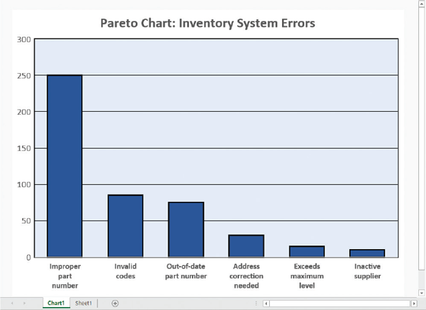
The XY chart, sometimes called a scatter diagram, is another problem-solving tool. Often, an analyst looks for a correlation between two variables. For example, suppose complaints are received about network response time, and the cause needs to be determined. The analyst would try to identify variables, such as the number of users, to see whether there is a correlation, or pattern. Figure 2-19 shows two XY charts with data samples. The first chart sample would suggest that there is no correlation between the delays and the number of users, so the analyst would look elsewhere for the source of the problem. However, if the data resembles the second XY sample, it indicates a strong relationship between the number of users and the longer response times. That information would be extremely valuable in the problem-solving process.
Figure 2-19
An XY chart shows correlation between variables, which is very important in problem solving. Conversely, a lack of correlation suggests that the variables are independent, and that you should look elsewhere for the cause.
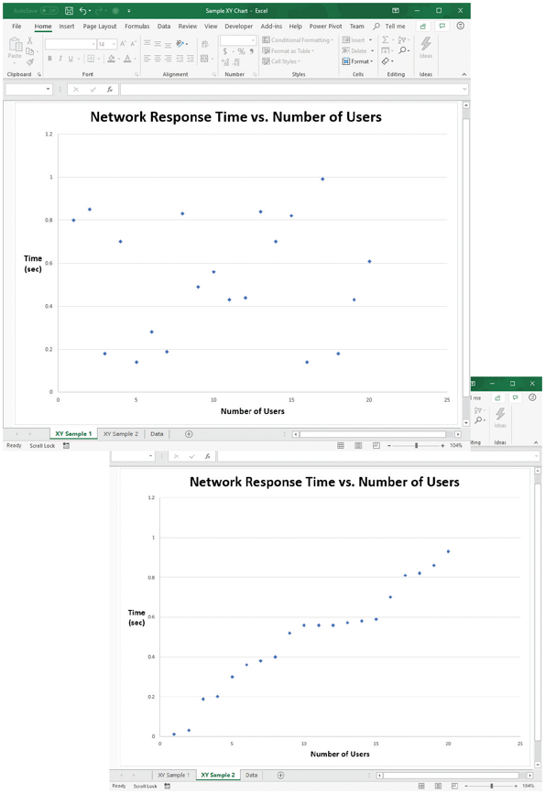

Step 4:Analyze Project Usability, Cost, Benefit, and Schedule Data
During fact-finding, data is gathered about the project’s predicted costs, anticipated benefits, and schedule issues that could affect implementation. Before feasibility can be evaluated, this data must be analyzed carefully. If interviews were conducted or surveys used, the data should be tabulated to make it easier to understand. If current operations were observed, the results should be reviewed and key facts that will be useful in the feasibility analysis highlighted. If cost and benefit data were gathered, financial analysis and impact statements can be prepared using spreadsheets and other decision-support tools.
Also, time and cost estimates should be developed for the requirements modeling tasks for the next SDLC phase, systems analysis. Specifically, the following should be considered:
- What information must be obtained, and how will it be gathered and analyzed?
- Who will conduct the interviews? How many people will be interviewed, and how much time will be needed to meet with the people and summarize their responses?
- Will a survey be conducted? Who will be involved? How much time will it take people to complete it? How much time will it take to tabulate the results?
- How much will it cost to analyze the information and prepare a report with findings and recommendations?

Step 5:Evaluate Feasibility
At this point, the problem or opportunity has been analyzed, the project scope and constraints have been defined, and fact-finding has been performed to evaluate project usability, costs, benefits, and time constraints. The next step is to assess the project’s feasibility, beginning with reviewing the answers to the questions listed in Section 2.7. The following guidelines should also be considered:

Operational Feasibility
Fact-finding should have included a review of user needs, requirements, and expectations. When this data is analyzed, look for areas that might present problems for system users and how they might be resolved. Because operational feasibility means that a system will be used effectively, this is a vital area of concern.

Economic Feasibility
Using the fact-finding data, financial analysis tools can be applied to assess feasibility. The cost-benefit data will be an important factor for management to consider. Also, a cost estimate for the project development team will be built into the project management plan.

Technical Feasibility
The fact-finding data should identify the hardware, software, and network resources needed to develop, install, and operate the system. With this data, a checklist can be developed that will highlight technical costs and concerns, if any.

Schedule Feasibility
The fact-finding data should include stakeholder expectations regarding acceptable timing and completion dates. As mentioned previously, often a trade-off exists between a project’s schedule and its costs. For example, compressing a project schedule might be possible, but only if the budget is increased accordingly to add extra personnel. The schedule data will be incorporated into the project plan in the form of task durations and milestones.
At this stage of the preliminary investigation, there are several alternatives. It might be that no action is necessary or that some other strategy, such as additional training, is needed. To solve a minor problem, a simple solution might be chosen without performing further analysis. In other situations, it will be recommended that the project proceed to the next phase, which is systems analysis.
Change font size
help
Main content

2.9.3Summarizing the Preliminary Investigation
The final task in the preliminary investigation is to summarize the results and recommendations, which can be conveying to management in a report and/or in a presentation. The written report and the oral presentation are examples of the need for systems analysts to develop strong communications skills. The report includes an evaluation of the systems request, an estimate of costs and benefits, and a case for action, which is a summary of the project request and a specific recommendation.
The specific format of a preliminary investigation report varies. A typical report might consist of the following sections:
- Introduction—the first section is an overview of the report. The introduction contains a brief description of the system, the name of the person or group who performed the investigation, and the name of the person or group who initiated the investigation.
- Systems Request Summary—the summary describes the basis of the systems request.
- Findings—the findings section contains the results of the preliminary investigation, including a description of the project’s scope, constraints, and feasibility.
- Recommendations—a summary of the project request and a specific recommendation. Management will make the final decision, but the IT department’s input is an important factor.
- Project Roles—this section lists the people who will participate in the project and describes each person’s role.
- Time and Cost Estimates—this section describes the cost of acquiring and installing the system, and the total cost of ownership during the system’s useful life. Intangible costs also should be noted.
- Expected Benefits—this section includes anticipated tangible and intangible benefits and a timetable that shows when they are to occur.
- Appendix—an appendix is included in the report if supporting information must be attached. For example, the interviews conducted might be listed, the documentation reviewed, and other sources for the information obtained. Detailed interview reports do not need to be included, but those documents that support the report’s findings should be retained for future reference.

A Question of Ethics
- iStock.com.com/faberfoto_itAs a new systems analyst at Premier Financial Services, you are getting quite an education. You report to the IT manager, who also chairs the systems review committee. Several months ago, the committee rejected a request from the finance director for an expensive new accounts payable system because the benefits did not appear to outweigh the costs.
Yesterday, the IT manager’s boss asked the IT manager to reconsider the finance director’s request, and to persuade the other members to approve it. The IT manager wanted to discuss the merits of the request, but the discussion was cut off rather abruptly. It turns out the IT manager’s boss and the finance director are longtime friends.
The IT manager is now very uncomfortable meeting with her boss. She believes the directive to reconsider the finance director’s request would undermine the integrity of the systems review process. She feels it would be unethical to grant preferred treatment just because a friendship is involved. She is thinking of submitting a request to step down as review committee chair, even though that might harm her career at the company.
Is this an ethical question, or just a matter of office politics? What would you do if you were the IT manager?
Change font size
help
Main content

2.10Summary
Systems planning is the first phase of the systems development life cycle. Effective information systems help an organization support its business processes, carry out its mission, and serve its stakeholders. During strategic planning, a company examines its purpose, vision, and values and develops a mission statement, which leads to goals, objectives, day-to-day operations, and business results that affect company stakeholders. SWOT analysis examines strengths, weaknesses, opportunities, and threats. SWOT analysis can be used at the enterprise level and for individual projects.
During the systems planning phase, an analyst reviews the business case, which is the basis, or reason, for a proposed system. A business case should describe the project clearly, provide the justification to proceed, and estimate the project’s financial impact.
Systems projects are initiated to improve performance, provide more information, reduce costs, strengthen controls, or provide better service. Various internal and external factors affect systems projects, such as user requests, top management directives, existing systems, the IT department, software and hardware vendors, technology, customers, competitors, the economy, and government.
During the preliminary investigation, the analyst evaluates the systems request and determines whether the project is feasible from an operational, technical, economic, and schedule standpoint. Analysts evaluate systems requests on the basis of their expected costs and benefits, both tangible and intangible.
The steps in the preliminary investigation are to understand the problem or opportunity; define the project scope and constraints; perform fact-finding; analyze project usability, cost, benefit, and schedule data; evaluate feasibility; and present results and recommendations to management. During the preliminary investigation, analysts often use investigative tools such as fishbone diagrams, Pareto charts, and XY charts. The last task in a preliminary investigation is to prepare a report to management. The report must include an estimate of time, staffing requirements, costs, benefits, and expected results for the next phase of the SDLC.
Change font size
help
Main content

Chapter Review

Key Terms
- biometric devices
- blockchain
- business case
- case for action
- computer resources committee
- constraint
- critical success factor
- customer relationship management (CRM)
- discretionary projects
- economic feasibility
- electronic data interchange (EDI)
- electronic product code (EPC)
- electronic proof of delivery (EPOD)
- encryption
- fishbone diagram
- intangible benefits
- intangible costs
- Internet-of-Things (IOT)
- just-in-time (JIT)
- mission statement
- nondiscretionary projects
- operational feasibility
- Pareto chart
- preliminary investigation
- project creep
- project scope
- scatter diagram
- schedule feasibility
- strategic planning
- SWOT analysis
- systems request
- systems review committee
- tangible benefits
- tangible costs
- technical feasibility
- total cost of ownership (TCO)
- XY chart
Change font size
help
Main content

Chapter Review

Key Terms
- biometric devices
- blockchain
- business case
- case for action
- computer resources committee
- constraint
- critical success factor
- customer relationship management (CRM)
- discretionary projects
- economic feasibility
- electronic data interchange (EDI)
- electronic product code (EPC)
- electronic proof of delivery (EPOD)
- encryption
- fishbone diagram
- intangible benefits
- intangible costs
- Internet-of-Things (IOT)
- just-in-time (JIT)
- mission statement
- nondiscretionary projects
- operational feasibility
- Pareto chart
- preliminary investigation
- project creep
- project scope
- scatter diagram
- schedule feasibility
- strategic planning
- SWOT analysis
- systems request
- systems review committee
- tangible benefits
- tangible costs
- technical feasibility
- total cost of ownership (TCO)
- XY chart
Change font size
help
Main content

Chapter Review

Key Terms
- biometric devices
- blockchain
- business case
- case for action
- computer resources committee
- constraint
- critical success factor
- customer relationship management (CRM)
- discretionary projects
- economic feasibility
- electronic data interchange (EDI)
- electronic product code (EPC)
- electronic proof of delivery (EPOD)
- encryption
- fishbone diagram
- intangible benefits
- intangible costs
- Internet-of-Things (IOT)
- just-in-time (JIT)
- mission statement
- nondiscretionary projects
- operational feasibility
- Pareto chart
- preliminary investigation
- project creep
- project scope
- scatter diagram
- schedule feasibility
- strategic planning
- SWOT analysis
- systems request
- systems review committee
- tangible benefits
- tangible costs
- technical feasibility
- total cost of ownership (TCO)
- XY chart
Change font size
help

